**Labs**

**CBC Interpretation**

|  |  |  |
| --- | --- | --- |
|  | **CBC w/o Differential** | **CBC w/ Differential** |
| **Indications** | Routine Screening | Infection (Bacterial vs Viral) |
| Baseline evals prior to surg or meds (w/ effects on bone marrow) | Hematologic disorders |
| Basic monitoring for chronic illnesses whose WBC subtypes is not main concern | Allergic Rxns & Parasitic Infections |
|  | Monitoring treatment like chemo |

**Quick Tips for Interpretation:**

* **Look at trends**
  + Compare with previous CBCs to see if there is a stable pattern or a significant change
* **Clinical correlation**
  + Always correlate CBC findings with clinical symptoms and other diagnostic results (Labs ≠ Patient Symptoms)
* **Ask about medications and recent events**
  + **A diagram of a flowchart

    Description automatically generated**Recent infections, surgeries, and medications can influence CBC results

**BMP v CMP Indications**

|  |  |  |
| --- | --- | --- |
|  | **BMP** | **CMP (adds LFTs)** |
| **Indications** | **Routine Checkups**  Assessing overall health status | **Nutritional Status Assessment**  Evaluating total protein and albumin levels for malnutrition. |
| **Chronic Conditions**  Monitoring patients with chronic conditions such as hypertension or kidney disease. | **Chronic Disease Monitoring**  Ex: Diabetes, Liver disease, and Chronic kidney disease |
| **Postoperative Monitoring**  Particularly in patients with known comorbidities like diabetes or chronic kidney disease, where electrolyte and renal function monitoring is crucial. | **Preoperative Assessments**  To evaluate overall metabolic health and liver function before surgery. |
| **Emergency Situations**  Used in emergency settings to quickly assess kidney function, electrolyte balance, and blood glucose levels. | **Evaluating Systemic Illnesses**  To assess metabolic derangements in various illnesses. |
| **Kidney Function Assessment**  To evaluate BUN and creatinine levels in patients with renal issues. | **Liver Disease**  To evaluate liver function through tests like ALT, AST, ALP, and bilirubin levels.  ***Symptoms: Jaundice, RUQ pain, hepatomegaly, or suspected liver disorders*** |
| **Diabetes Management**  To monitor glucose levels in diabetic patients. | **Monitoring Medication Effects**  Especially drugs that affect liver or kidney function. |
| **Dehydration**  Monitoring electrolyte levels in patients with suspected dehydration. |  |
| **Electrolyte Imbalances**  ***Symptoms: Muscle weakness, fatigue, or arrhythmias.*** |  |
| **Acid-Base Disorders**  To evaluate bicarbonate levels in cases of metabolic acidosis or alkalosis. |  |
| **Monitoring Patients on Diuretics**  To check for electrolyte changes. |  |

**Electrolyte Basic Interpretation**

**Etiologies for each electrolyte deficiencies:** [**https://clinicalproblemsolving.com/reasoning-content/dx-schema-electrolytes/**](https://clinicalproblemsolving.com/reasoning-content/dx-schema-electrolytes/)

**LFTs Basic Interpretation**

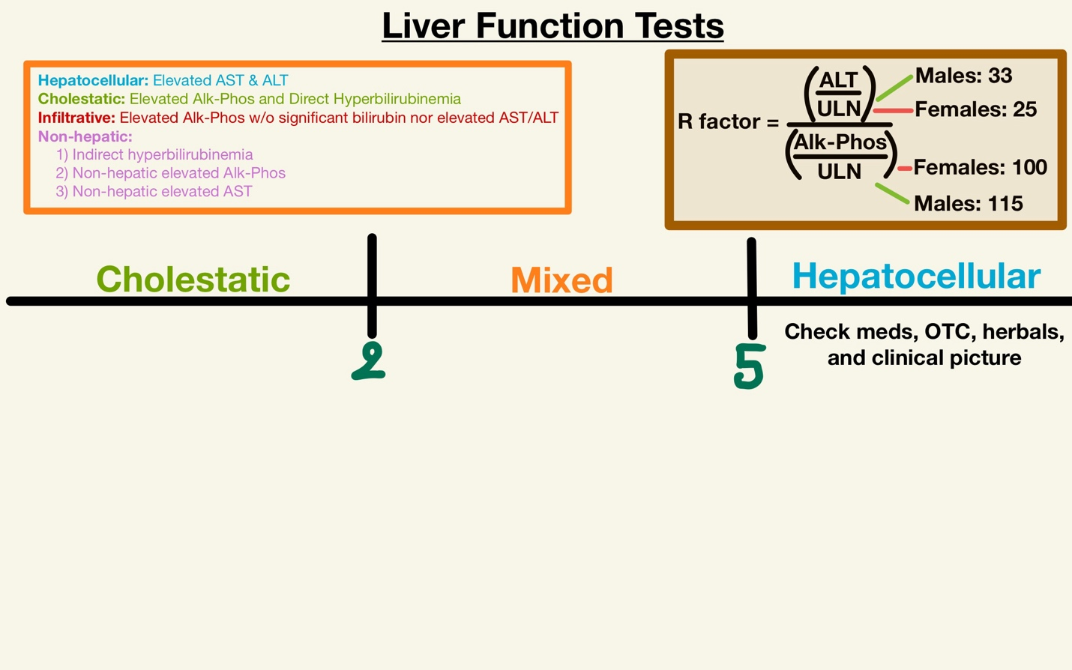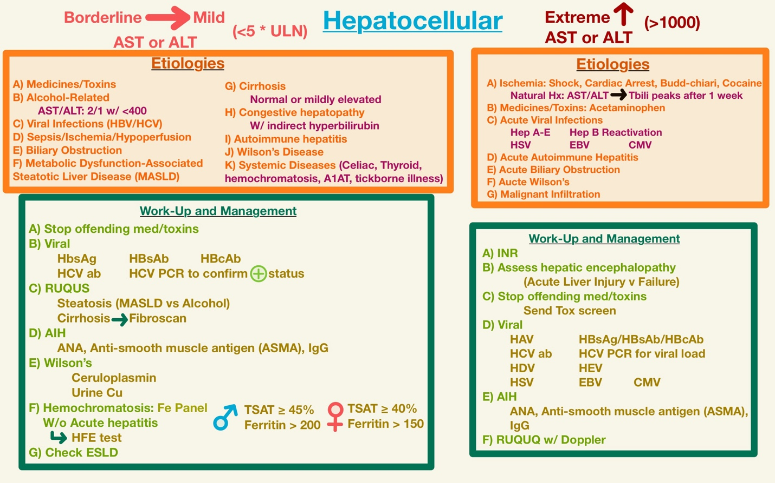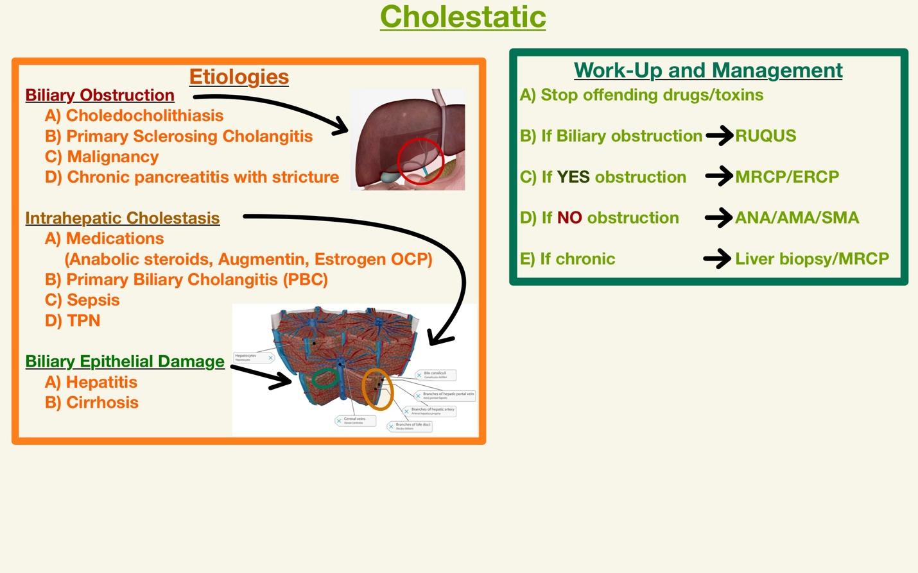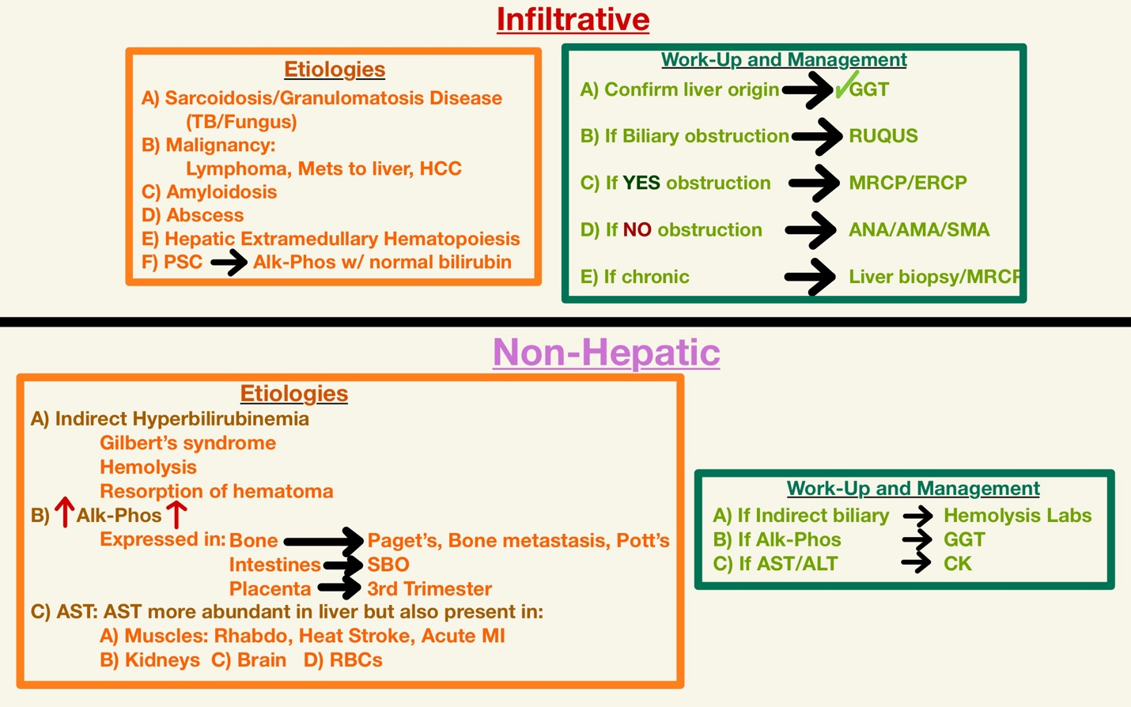

**Hemodynamic Interpretation**

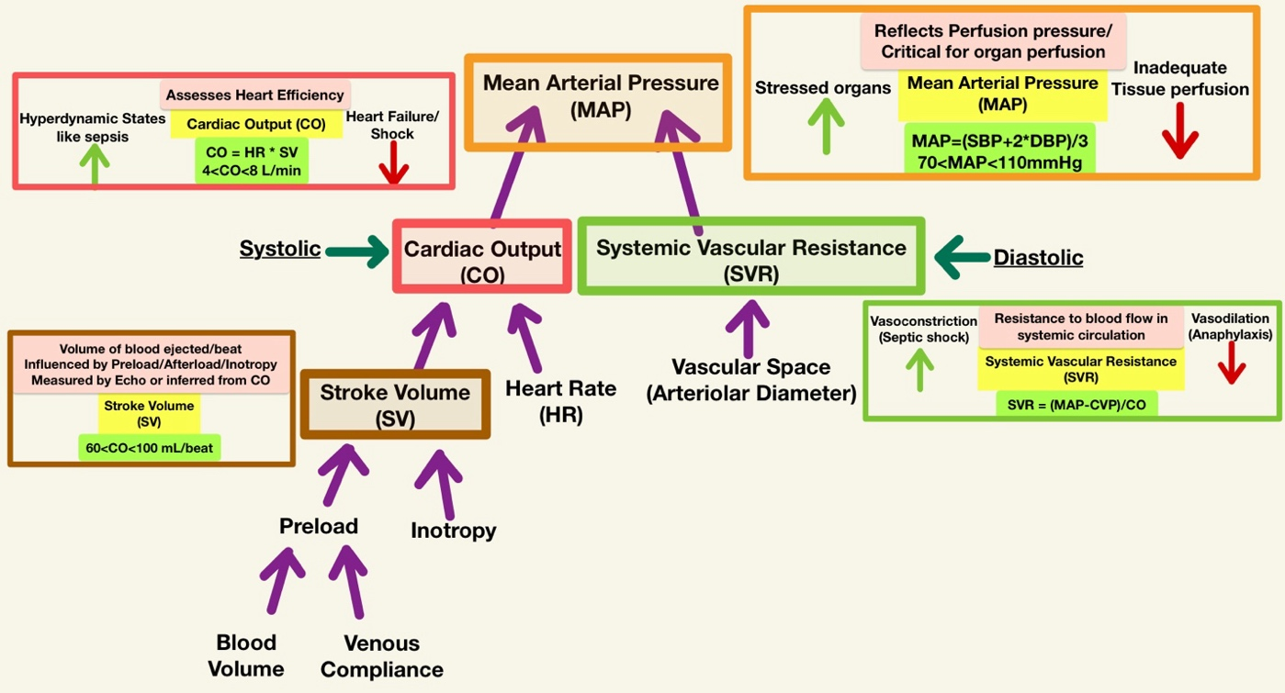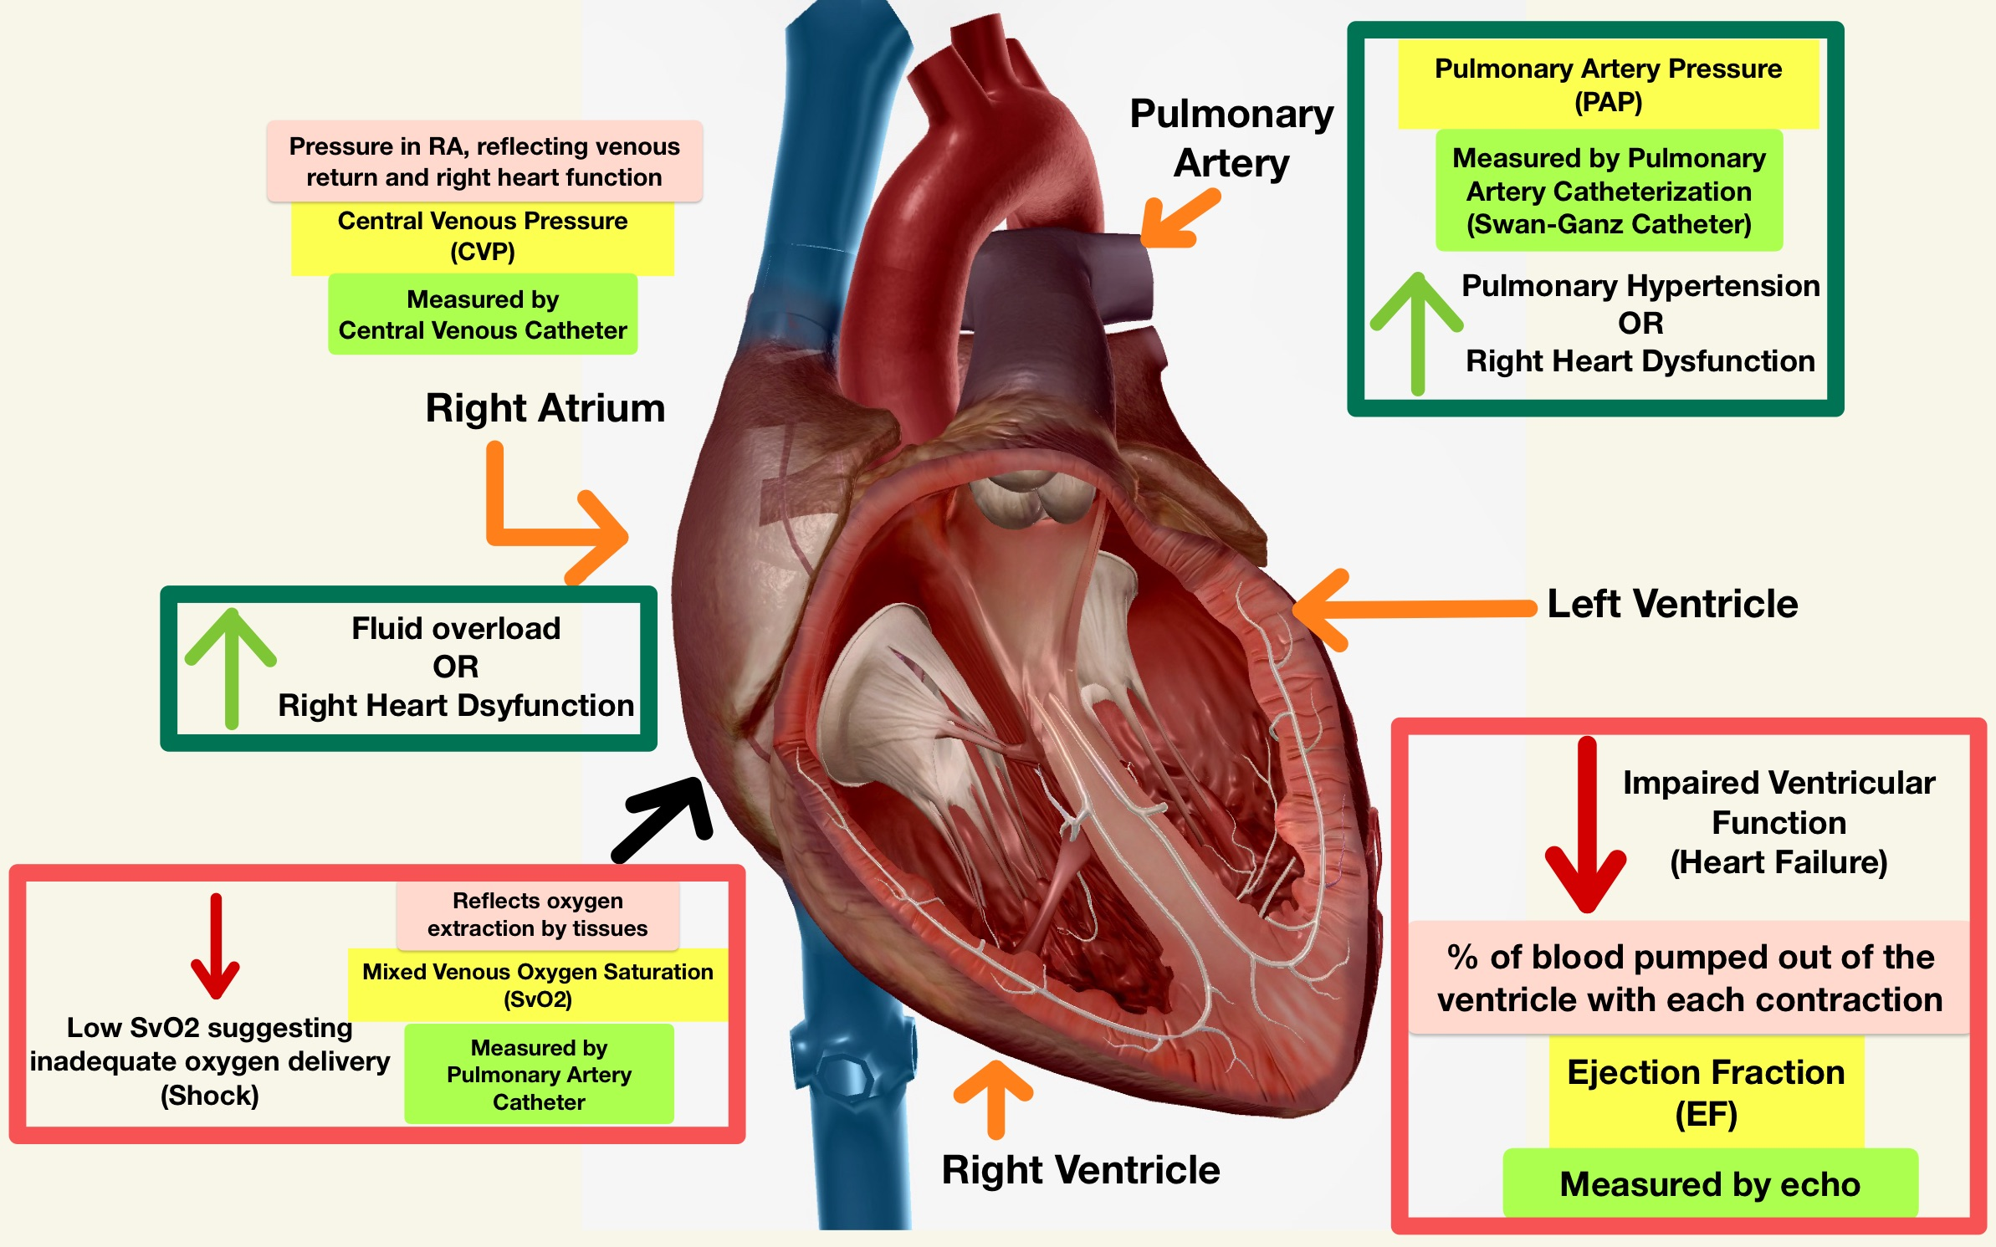

**Clinical Integration:**

* **Clinical Contextual Interpretation:** Consider clinical context (e.g., trauma, sepsis) when interpreting hemodynamic data
* **Monitoring and Treatment:** Hemodynamic monitoring guides fluid resuscitation, vasopressor use, and other interventions to optimize perfusion and cardiac function